POL 242Y
May 26, 2008

- Formulate a hypothesis describing relationship between political views and religiosity. Identify the dependent variable and the independent variable.

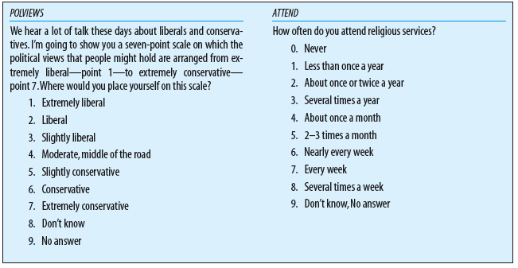

2. Professor Josephson researched the effects of political orientation on attitudes toward immigration. Political orientation is an example of
a. an attribute.
b. an independent variable.
c. an aggregate.
d. a unit of analysis.
e. a dependent variable.
3. Which measure of central tendency divides the distribution into two halves?
a. dispersion
b. mode
c. marginal
d. median
e. mean

4. Which one of the following is an example of a frequency distribution of grouped data for age?
a. 18-25, 40 people; 26-50, 60 people; over 50, 20 people
b. 18, 10 people; 19, 11 people; 20, 26 people; 21, 15 people
c. 26, 28, 28, 30, 31, 33, 35, 41, 41, 50
d. the mean age is 45.1
e. the median age is 38.6

5. The grades on a final test for a political science class are as follows: 25% As, 35% Bs, 30% Cs, 9% Ds and 1% Fs. The modal grade (the mode) of the class is
a. A
b. B
c. C
d. D

6. Professor Dorn analyzed the relationship between age and voting behavior. This is an example of which type of analysis?
a. univariate.
b. bivariate.
c. multivariate.
d. descriptive.
e. ex post facto.

7. Which measures of central tendency can be used to describe the following variables?

a. Religious affiliation (Catholic, Jewish, Muslim, Protestant, Other)
b. GDP per capita ($)
c. Education (years)
d. Defence spending as % of government budget
e. Socio-economic class (lower, working, middle, upper)

a
b
c
d
e

