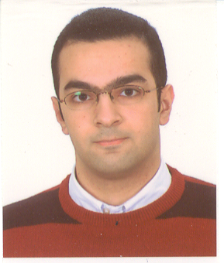
Imad Halim Azzam
Alternative Spelling: Emad Halim Azzam
Date of Birth: 17/11/1985
Email: iazzam@comm.utoronto.ca
Telephone Number: +1 416 827 8428

Objective:
Seeking a job for a graduate, related to Computer and Communications Engineering, preferably communications, networking, or programming.

Education:
- September 2006 − April 2008
Masters of Applied Science, Communications Group
University of Toronto
- September 2002 – February 2006:
Bachelor of Engineering, Computer and Communications Engineering (CCE), American University of Beirut (Expected Date of Graduation: July 2006)
  - Major Courses Completed or In Progress
  - GPA: 91.56 out of 100

- September 1999 – July 2002
High School Degree, International School of Choueifat, Choueifat - Lebanon

Projects:
- Final Year Project Title: FPGA Implementation of LMMSE Detector for a MIMO OFDM Communication System for Performance Analysis
- Transistor-Level Design and Cadence/Virtuoso Implementation of the $\text{ln}\left(\frac{e^{x+y}+1}{e^{x}+e^{y}}\right)$ Function (used in communication systems)
- Designed and Implemented a Web-Application using Microsoft Visual Studio .NET (ASP.NET, C#, and mySQL) (intended for a PC-gaming website)
- Design and VHDL Implementation of a 26-Instruction, MIPS-based, Multi-Cycle, RISC processor
- C Projects:
  - Network Bridge Protocol/Minimum Spanning Tree Algorithm
  - Simplified FTP Client (Socket Programming)
Qualifications:
- Experienced in VHDL (Very High Speed Integrated Circuits Hardware Description Language)
- Experienced in MATLAB 7.1
- Experienced in LabView 7/8 and related National Instruments equipment
- Experienced in HTML, XHTML, DHTML, ASP.NET, C# as related to Web Server Design and Programming
- Experienced in C++ Programming in a Windows Environment
- Experienced in C Programming in a Linux Environment
- Basic experience in Cadence and Virtuoso (transistor-level layout and testing of microchips)
- Basic experience in PSpice circuit design and simulation

Nationality:
Lebanese

Awards:
- University of Toronto Fellowship + Research Assistantship

- Faculty of Engineering and Architecture Dean’s Honor List: All semesters attended at university

Work Experience:
  - Worked as a Professional Services Consultant at NCR, Lebanon from July 1, 2006 to September 15, 2006 mainly in ASP.NET programming and database management using Teradata and related applications.

  - Worked for two months during the summer of 2005 at Emirates Computers, Dubai, a leading computer company in the United Arab Emirates, mainly with servers, clusters and storage and Cisco routers, switches and access points.

  - Worked for six semesters in the Electrical and Computer Engineering Department with an electrical engineering professor (preparing course material and maintaining website)

Memberships:
Professional: - Student Member of the IEEE

Languages:
Arabic: Native
English: Excellent (Writing, Reading, and Speaking)
French: Basic

References:
Available upon request.

