Dharma Class Lesson Notes

Date: March 30, 2002
Time: 7:30 p.m. – 9:00 p.m.
Topic: Twelve Links ~ The Cycle of Dependent Origination (cont’d)
Teacher: Vincent Ng

During this class, the teacher continued the 12 links of life and death.
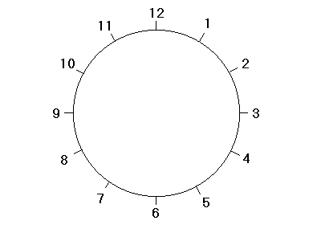
EXPERIENCE, LIFE
- Ignorance
- Mental Formation
- Consciousness
- Name and Forms
- Sense Bases
- Contact
- Feelings
- Craving
- Clinging (attachment)
- Becoming
- Rebirth
- Death, Aging
There are two ways to look at the world, positive and negative. You have to choose what is better for you.

The senses include your ears, nose, eyes, body, tongue and mind. You cannot control what you sense. By sensing, you come into contact with the things and create feelings. You cannot control your senses. However, you can control your feelings. Do not let the feelings control the consciousness of the mind.

Firstly, to stop craving, you have to be content with what you already have, and, at the same time, you have to be content with what you do not have. To have the result, you must proceed from the very root (cause) of the effect.

To escape from the circle of life, practice morality, concentration and wisdom – the three things that we are not aware of during the experience of life.

To break the chain, we follow the Five Precepts and the Noble Eightfold Path.
- no killing
- no lying
- no stealing
- no sexual misconducts
- no alcohol
- no harsh words
- no idle chat
- mindfulness
- concentration
- wisdom
- right understanding
- right thought
- right speech
- right action
- right livelihoods
- right effort
- right mindfulness
- right concentration.

When you have done something wrong, lying or further lying will not help the issue at all. People close to you can steer you towards the right path to take.

Idle talk will not help you with your wisdom and concentration.

When you see a flower, you feel for it, crave for it, and so you take it. With that action you have fallen into the life circle. You sense, feel, crave and create an attachment to it. You also violated the Five Precepts. Killing: the flower. Stealing: the flower is not yours. To end this circle, you must have control over your own feelings. You cannot stop the sense, but you can stop the strong feeling of wanting, and therefore, breaking the cycle at point #7: feeling.

There are different levels to stop yourself from picking up the flower:

- From the second of the six Paramitas, morality / precepts, you understand that you should not pick up any flowers that do not belong to you. Otherwise, you will break the precepts of stealing and killing (i.e. the flower). In this case, an external force guides you from accumulating bad karma due to your actions and speech. You will have prevented yourself from Clinging (9), therefore, morality helps stop the cycle by not taking things ~ in other words, making the thing become (10) yours.

- However, from further introspection, you can stop and correct yourself to an even greater extent by concentration, because then you will be mindful of what you are doing. No bad intentions such as picking the flower will arise. You are in control of your thoughts, and understand that you are not supposed to cling (9) to the flowers. Consequently, you will not develop any craving (8). This will stop the mind from creating karma because you have practiced two components of the Noble Eightfold Path: Right View/Understanding and Right Thought.

- The best way to break the chain is with wisdom – to see the truth of emptiness. You realize that the flowers are not “real,” because they are only the combination of different causes and conditions. So, when your senses contact (6) the flowers, you do not even develop feelings (7), and so the intention of any action will stop. As this moment, you just “see” the flower, and nothing more.

